**Project: Analyzing a Market Test**

## Step 1: Plan Our Analysis

1. What is the performance metric we’ll use to evaluate the results of your test?

*Gross margin is the best performance metric we should use since we are interested in profits rather than costs or revenues.*

1. What is the test period?

*12 weeks start from 2016-April-29 to 2016-July-21.*

1. At what level (day, week, month, etc.) should the data be aggregated?

*Week is a good period cycle to monitor all customers’ behavior.*

## Step 2: Clean Up Our Data

*Firstly, I’ve checked data with interesting fields only, there is no missing, incomplete, duplicate. I have resolved some issues that would help in getting data prepared before analysis process:*

1. *In ‘RoundRoastersTransactions.csv’, some fields like Invoice_Date, QTY, Gross Margin, and Sales are converted to their proper data type.*
2. *The store sales transactions have been filtered to keep only transactions with dates between 2015-February-06 and 2016-July-21 (76 weeks).*
3. *The store sales transactions have been aggregated by each week for each store.*
4. *Listing all stores with classifying whether a store is a treatment or not by using ‘treatment-stores.csv’.*
5. *Joining store class list with ‘round-roaster-stores.csv’ in order to add AvgMonthSales field.*

## Step 3: Match Treatment and Control Units

1. What control variables should be considered?

*Average Monthly Sales and area square feets for each store.*

1. What is the correlation between our potential control variables and our performance metric?

*Using the following correlation matrix, we found that area square feets doesn’t affect the gross margin profit but Average Monthly Sales strongly do.*

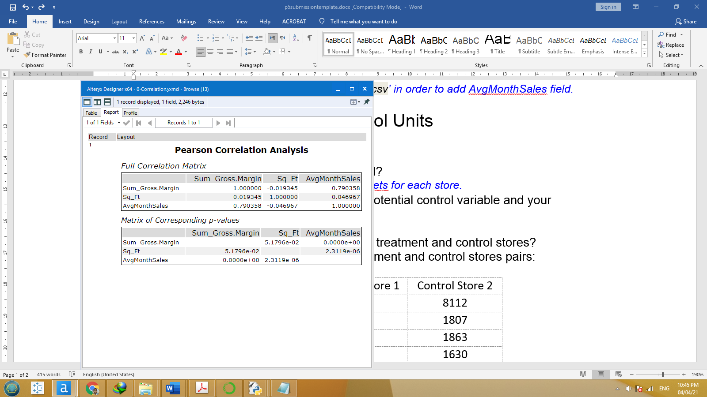

1. What control variables will we use to match treatment and control stores?

*In addition to trend and seasonality we should use* *Average Monthly Sales too.*

1. The table below represents our treatment and control stores pairs:

|  |  |  |
| --- | --- | --- |
| Treatment Store | Control Store 1 | Control Store 2 |
| 1664 | 7162 | 8112 |
| 1675 | 1580 | 1807 |
| 1696 | 1964 | 1863 |
| 1700 | 2014 | 1630 |
| 1712 | 8162 | 7434 |
| 2288 | 9081 | 2568 |
| 2293 | 12219 | 9524 |
| 2301 | 3102 | 9238 |
| 2322 | 2409 | 3235 |
| 2341 | 12536 | 2383 |

## Step 4: Analysis and Writeup

*Answer these questions. Be sure to include visualizations from your analysis:*

1. What is our recommendation - Should the company roll out the updated menu to all stores?

*The company should roll out the updated menu to all stores as a comparison of the treatment-control pairs indicates an average lift in Sum Gross Margin for the treatment units over the control units of 40.4%, which results in an expected impact of 680.9 with significance level 100%.*

1. What is the lift from the new menu for West and Central regions (include statistical significance)?

*The lift for Central region is 44.5% while the lift for West region is 36.3% and both have a statistical significance of 99.6% and 99.5% respectively.*

Central Region Gross Margin

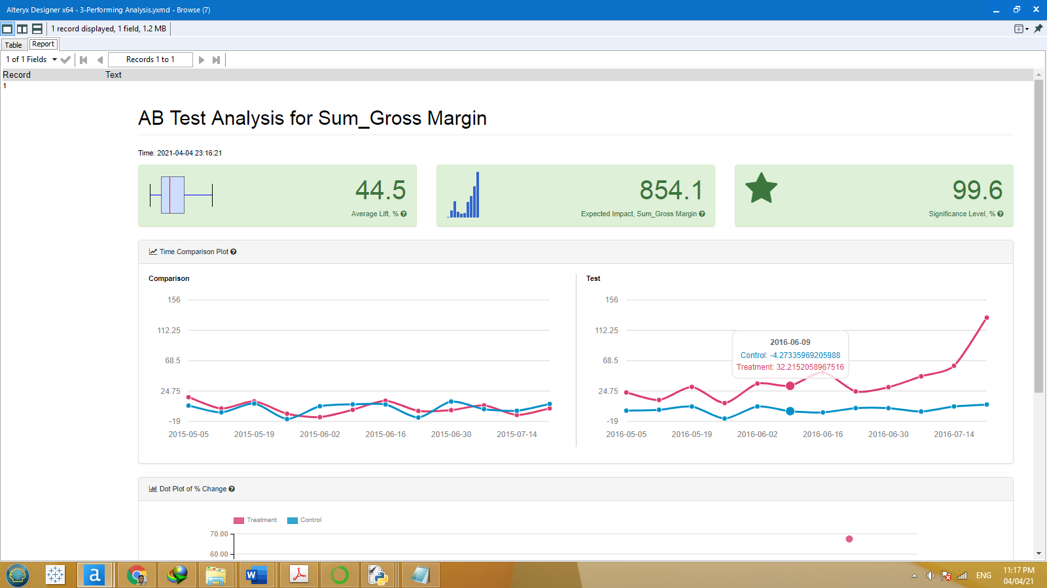

West Region Gross Margin

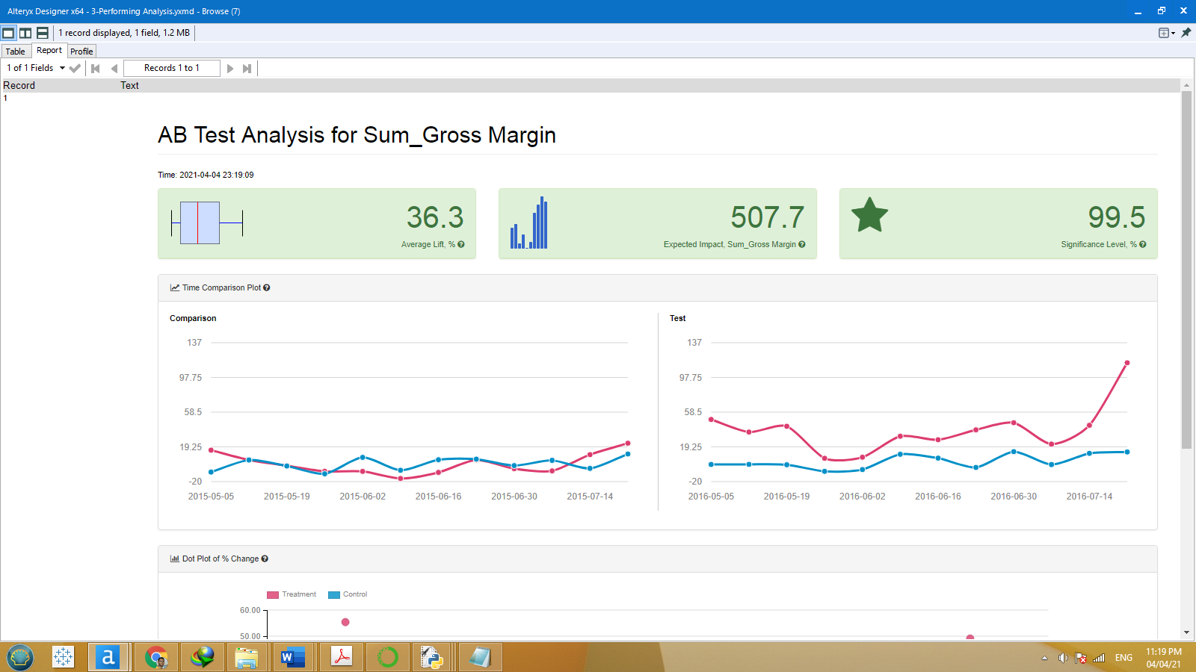

1. What is the lift from the new menu overall?

*The overall lift is 40.4% with a significance level 100%.*

Overall Gross Margin

